

**Selling, Marketing & Distributing Film:**

**The Process, Demystified with Mia Bays**

**VENUE:** LFS Workshops Space, 2nd Floor, 33 Long Acre London WC2E 9LA

This 2-day intensive has been running annually or bi-annually for over 10 years now and aims to demystify the distribution, marketing and sales process for filmmakers, for those interested in the sector, and for executives from other areas of film who want to understand how this crucial part of the industry works.

We cover documentary and fiction and there will be case studies and a focus on British film as well as international independent and studio titles, so the whole industry is encompassed.

This year’s session takes place Friday July 6 and Sat July 7 and costs £300 including a networking drinks event on Friday evening.

Workshop web page link:

<http://lfs.org.uk/workshops/lfs-workshops/267/selling-marketing-distributing-film-process-demystified>

All attendees to complete this survey by Thursday 5th July 3pm: <https://goo.gl/forms/egSSsQeGRSzcMvY72>

**CONTACTS:**

Mia Bays 07770594682 [info@miafilms.co.uk](mailto:info@miafilms.co.uk), @miafilms

Catherine Pearson [c.pearson@lfs.org.uk](mailto:c.pearson@lfs.org.uk)

**Day One – Friday 6th July 2018**

9.45 – 10.00 REGISTRATION & REFRESHMENTS

10-10.30 **Introduction** to workshop by Mia Bays, group intro

10.30 – 11.30 **The Film Value Chain – how it works, how sales revenues work, how box office is tallied: THE ECONOMICS OF FILM (with Mia Bays)**

**11.30-11.45 Break**

**11.45-13.00 International Sales Presentation**: Matt Baker, Head of Production and Acquisitions for Hanway (BROOKLYN, CAROL, ANOMALISA) on production and finance from an international POV including sales strategies and case studies

13.00-14.00 Lunch

14.00-15.15 **Kristin Ryan, Director of Marketing, Home Entertainment at one of the UK’s leading film distributors Studio Canal** discussing how to define your audience and define a marketing strategy to reach them in the Home Ent space.

15.15-16.15 **Kate Muir, one of the UK’s leading film critics and film feature writers** (previously of The Times, now writes for The Guardian, The Pool amongst many) will join us to talk about the role of film criticism and feature writing and filmmaker championing in the film value chain.

16.15-16.30 BREAK

16.30 – 17.30 **Lydia Penke, Curzon Cinemas**

Insights into how a cinema programmer works, how films and events are booked and profiled at one of the leading specialised cinema chains

17.30 – 18.30 **Networking Drinks**

**Day Two – Saturday July 7th 2018**

9.45 – 10.00 REFRESHMENTS

**10.00-11.00 Setting the scene – with Charles Gant, film critic and editor of the Guardian Box Office blog -** discussingBox office, trends and genre in the UK

11.00-12.00 **Andrew Woodyatt** on in-cinema marketing and how to manage key partnerships

12.00-13.00 **Andrew Woodyatt** on social media strategy for film

13.00-14.00 LUNCH BREAK

14.00-15.00 **Paul Ridd, Head of Acquisitions at Picturehouse Entertainment (one of the UK’s leading distributors and cinema chains)** shares insights on buying theatrical films – the big titles and spotting the breakout underdogs (he was a key member of the team who bought GOD’S OWN COUNTRY, THE PARTY, IN CUSTODY)

15.00-16.00 **Mia on specialised distribution, exhibition and audience development** – through her work at Birds Eye View and as a distribution strategist

16.00-16.15 Break

16.15-17.15 **Festivals & Sales 101 with Mia**: the key festivals, how they link with thinking of how to get a deal, what stage do you contact, film fest strategy, marketing and positioning

17.15-18.00 SUMMARY AND CLOSE OF DAY TWO – Discussion and Q&A with Mia to pull all the topics together and ask your own project-specific questions.



**BIOGRAPHIES**

**[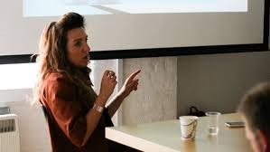](https://www.google.com/imgres?imgurl=https://northernmedia.org/wp-content/uploads/2018/01/Mia-Bays-LFS.jpg&imgrefurl=https://northernmedia.org/event/script-screen-producers-filmmakers-bootcamp-mia-bays-15-16-feb/mia-bays-lfs/&docid=R9Lpj_Q_jsnVqM&tbnid=spk7bVgBu5JrZM:&vet=10ahUKEwjKkfqSpf7bAhWEIcAKHVl3Dw0QMwhBKAcwBw..i&w=600&h=338&client=firefox-b-ab&bih=824&biw=1440&q=mia%20bays&ved=0ahUKEwjKkfqSpf7bAhWEIcAKHVl3Dw0QMwhBKAcwBw&iact=mrc&uact=8)**

**MIA BAYS** is a producer with 13 feature and 4 short film credits, including an Oscar winner for Best Live Action Short (Six Shooter 2006) and Best Debut Carl Foreman for Scott Walker – 30 Century Man 2007 and 27 years in film as of 2018. She works across fiction and docs, with a proven track record of launching careers (having worked on the early films of Martin McDonagh, Lucy Walker, Eran Creevy, Riz Ahmed and Ben Whishaw to name a few).

She started her career in independent exhibition, distribution and sales, working on films such as Ang Lee’s THE WEDDING BANQUET and selling films such as Ian McKellen’s RICHARD III for Mainline Pictures/Screen Cinemas.

Mia has produced since 2004 – her first was SIX SHOOTER the Oscar winning film by Martin McDonagh, acclaimed music doc SCOTT WALKER 30 CENTURY MAN featuring David Bowie, Jarvis Cocker and Damon Albarn by Stephen Kijak, with whom she also completed BACKSTREET BOYS – SHOW EM WHAT YOURE MADE OF which premiered Jan-July 2015 worldwide on over 1500 screens and went to No1 on iTunes in N.America. Her latest film LETTERS FROM BAGHDAD voiced by Tilda Swinton has grossed over £100,000 in the UK, which is one of the highest of the year for a documentary.

From 2007-14 Mia made 8 micro budget features as Creative Producer for the acclaimed Film London BBC Films Microwave scheme, including one of the most acclaimed UK debuts of 2008, SHIFTY by Eran Creevy which won Best Script at Stockholm Film Festival and garnered a BAFTA nomination for Best Debut 2010, and LILTING starring Ben Whishaw which opened Sundance Film Fest 2014 World Dramatic section and sold to over 16 territories inc Scandinavia and North America (Strand) and was nominated for a BAFTA for Best Debut 2015.

Mia now runs Birds Eye View Film are a film agency and film agitator marketing films by women to audiences to effect industry change. BEV celebrate 15 years of charity work this year, with a new vision for 2017-2020 building on their 25k+ reach on social media channels and heavy hitting board and reach in the industry to make a greater impact on the industry and audience by showing that films by women have commercial reach, and by connecting filmmakers and female executives to the market more closely in order to effect real change. You can sign up to their RECLAIM THE FRAME project, to be a screen influencer, here <https://www.birds-eye-view.co.uk/influencers/>

In 2018 she produced Sundance Film Festival: London – it was the most successful year to date (attendance and coverage) with a 58% female-directed feature programme (with guests such as Debra Granik, Jennifer Fox, Ethan Hawke, Toni Colette and Idris Elba in attendance).

[www.miafilms.co.uk](http://www.miafilms.co.uk/)

[info@miafilms.co.uk](mailto:info@miafilms.co.uk)

[www.birds-eye-view.co.uk](http://www.birds-eye-view.co.uk) @birdseyeviewff @miafilms

**SPEAKERS**

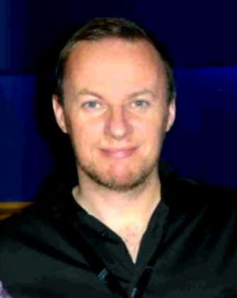**ANDREW WOODYATT** is a multi-award winning film marketeer, having spent fifteen years in exhibition running multiplex cinemas and programming them for the UCI chain, then as Marketing Director at Picturehouse Cinemas, and then spending twelve years in film distribution at Lionsgate creating campaigns for BAFTA winning titles like The Lives Of Others and I've Loved You So Long, to Head of Marketing at Revolver and Metrodome winning seven Screen Marketing Awards for innovative and ground breaking marketing campaigns.

Andrew now works as a marketing consultant with film producers to develop and shape feature projects, he also works as a film lecturer teaching MA students at the Met Film School, London Film School and at Goldsmiths.

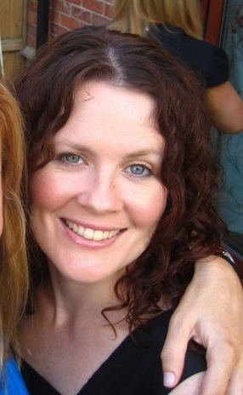

**KRISTIN RYAN** is a marketing professional with over 20 years’ experience in UK film distribution. She is currently Director of Marketing, Home Entertainment, at Studio Canal UK, overseeing the home entertainment releases of films such as Paddington 1 and 2 and LEGEND starring Tom Hardy. Adept management and team leadership skills, able to balance the commerical and creative aspects of leading a successful marketing team with consistently strong sales results in a changing distribution landscape.

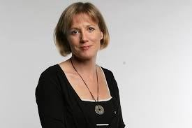

**KATE MUIR** is a Scottish novelist and editor. She worked at The Times as the chief film critic for 7 years and left in 2017 to work full time as a critic and novelist. Kate is the author of three novels, and her next non-fiction book is on women in film. She is the UK contact for key agitator for equality in film Women and Hollywood and is on the board of Birds’ Eye View Film, whose mission is to bring ever greater audiences to films by women in the UK.

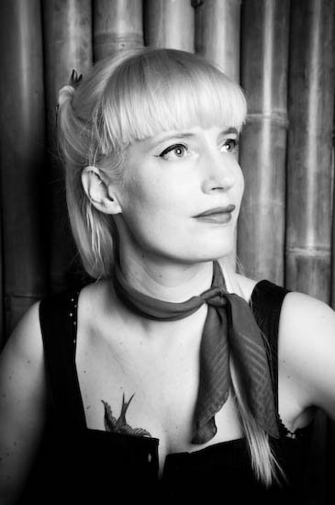

**LYDIA PENKE** has been programming Curzon cinemas for four years, including VR. Previously she worked at the London Film School, BFI London Film Festival, Film Education, on the Film: 21st Century Literacy strategy, The Hospital Club and Arts & Business. She studied at The University of Manchester.

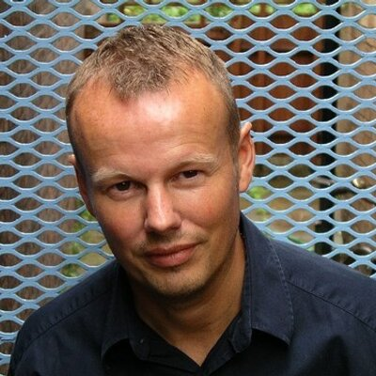

**CHARLES GANT** is a film critic and film writer for many key publications who also conducts weekly analyses of the UK box office results, published in The Guardian.

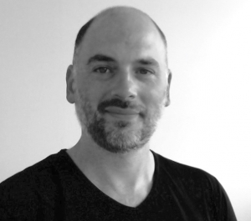

**MATT BAKER** – Director of Acquisitions and Production at Hanway Films. Born in London, England, to a filmmaking family, Matthew Baker worked briefly in casting before joining Jeremy Thomas’s production company, Recorded Picture Company in August, 2000. He worked in development for RPC until 2004, when he officially moved over to HanWay Films, RPC’s sister sales company, to handle acquisitions.

Whilst at RPC he worked on projects including ‘The Dreamers’, directed by Bernardo Bertolucci, ’Sexy Beast’, directed by Jonathan Glazer, ‘Young Adam’, directed by David Mackenzie and Rabbit-Proof Fence, directed by Philip Noyce.

At HanWay, credits include ‘Match Point’ (dir. Woody Allen) ‘Away From Her’ (dir. Sarah Polley), ‘Nowhere Boy’ (dir. Sam Taylor Wood), ‘Super’, (dir. James Gunn), ‘Shame’, (dir. Steve McQueen), ‘Seven Psychopaths’, (dir. Martin McDonagh), ‘Quartet’, (dir. Dustin Hoffman), ‘You’re Next’ and ‘The Guest’, (dir. Adam Wingard) and most recently ‘Brooklyn’, (dir. John Crowley), ‘Anomalisa’, dir. Charlie Kaufman and Duke Johnson) and ‘Carol’ (dir. Todd Haynes).

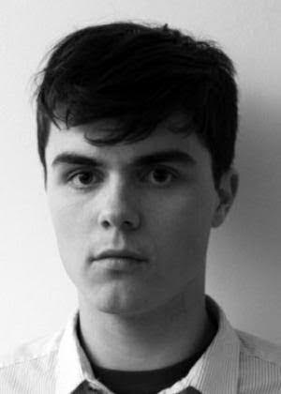

**PAUL RIDD** joined Picturehouse in 2011 as a programmer and has since moved full time into acquisitions for the company's distribution arm, Picturehouse Entertainment. He is responsible for tracking, screening and acquiring feature films for the company. Recent releases include GOD'S OWN PARTY, THE PARTY, CUSTODY and the forthcoming FIRST REFORMED.  Paul is also a Programmer for Sundance Film Festival London which is held in May at Picturehouse Central.